Multiplying two proper fractions: 3/4 × 5/8

First choose which fraction you will start with, and make sure your in-words explanation tells which fraction does which job.

3/4 × 5/8 means that there are sets of size 3/4 of a unit of stuff, and we want 5/8 of such a set.
3/4 × 5/8 tells how many units of stuff are in this amount.
(Note: this means exactly the same as 5/8 of 3/4 and it means the opposite of 3/4 of 5/8)

I start by showing 3/4 by partitioning a whole into 4 equal pieces and shading 3 of them.
If you use grid paper, explain that you’re going to make a 4x8 rectangle on which to show 1 whole. I strongly recommend rectangles or squares for multiplication.

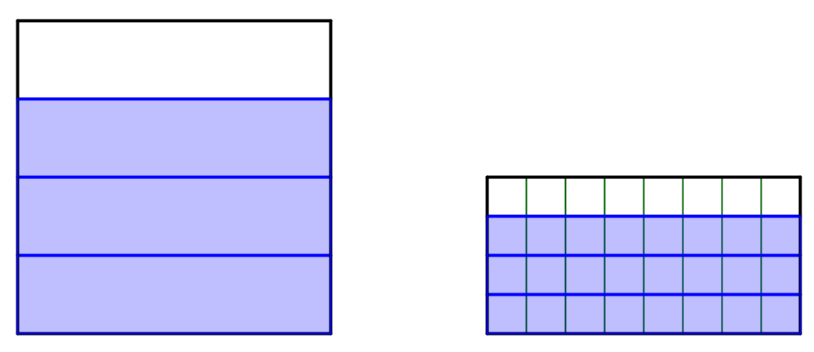
Now partition each of the fourths into 8 pieces by subdividing in the opposite direction.
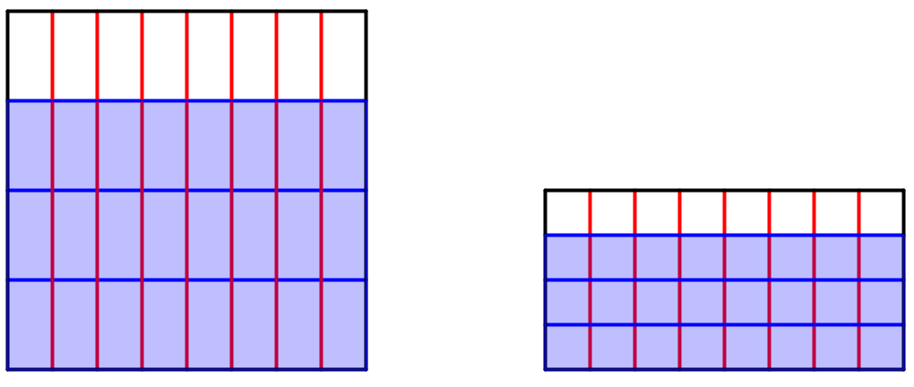
Show how much 5/8 of the 3/4 is by shading 5/8 of the part that’s shaded blue (the 3/4) in another color.

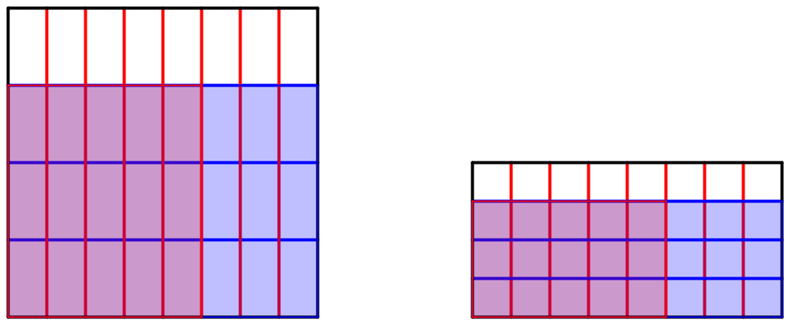

- This picture, along with my explanations of how I made it satisfies: Use a visual model
- And also: Explain in words the rationale for the visual model (can be either fraction of a fraction or rectangular area). My picture shows 5/8 taken of a set of size 3/4, so my model matches the words.
Note: you only need to show the final picture—not all three.

Now the whole square/rectangle that I started with was 1 unit of stuff. The blue part was 3/4 of a unit of stuff, and the red/purple is 5/8 of 3/4 of a unit of stuff. So—how many units is that?

I need to know how many boxes are in a whole unit of stuff. To partition the unit, I first made 4 parts and then I split each of those 4 into 8 parts, so a unit contains 4×8 boxes. One way to figure out how many boxes there are is to count the number of rows (4) and columns (8) in the whole unit. You can multiply rows × columns to find the total number of boxes in the whole.

I need to know how many boxes are in 5/8 of 3/4: that’s the red/purple part. I can count the number of rows (3) and the number of columns (5) and multiply those to find the number of boxes in the product:

So the product is 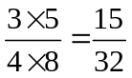 units.
Notice that the number of red parts is the product of the two numerators, and the number of parts in a whole is the product of the two denominators.

- In these paragraphs: The numerical strategy is shown
- And: There is an in-words explanation of how the numerical steps are shown in the diagram. This should include both:
  - How the numerator and the denominator values are shown in the diagram When I say/show that the number of parts in the red-shaded rectangle is the numerator, and the number of parts in a whole is the denominator I am doing this.
  - How the products can be deduced from the diagram (what to multiply together and why). When I explain that I am getting numbers from the rows and columns or recalling how I partitioned the whole I am doing this part.

Multiplying two improper fractions: 5/4 × 15/8

First choose which fraction you will start with, and make sure your in-words explanation tells which fraction does which job.

5/4 × 15/8 means that there are sets of size 5/4 of a unit of stuff, and we want 15/8 of such a set.
5/4 × 15/8 tells how many units of stuff are in this amount.
(Note: this means exactly the same as 15/8 of 5/4 and it means the opposite of 5/4 of 15/8)

I start by showing 5/4 by partitioning a whole into 4 equal pieces and adding another piece of that size to show 5/4 of them.
If you use grid paper, explain that you’re going to make a 4x8 rectangle on which to show 1 whole.
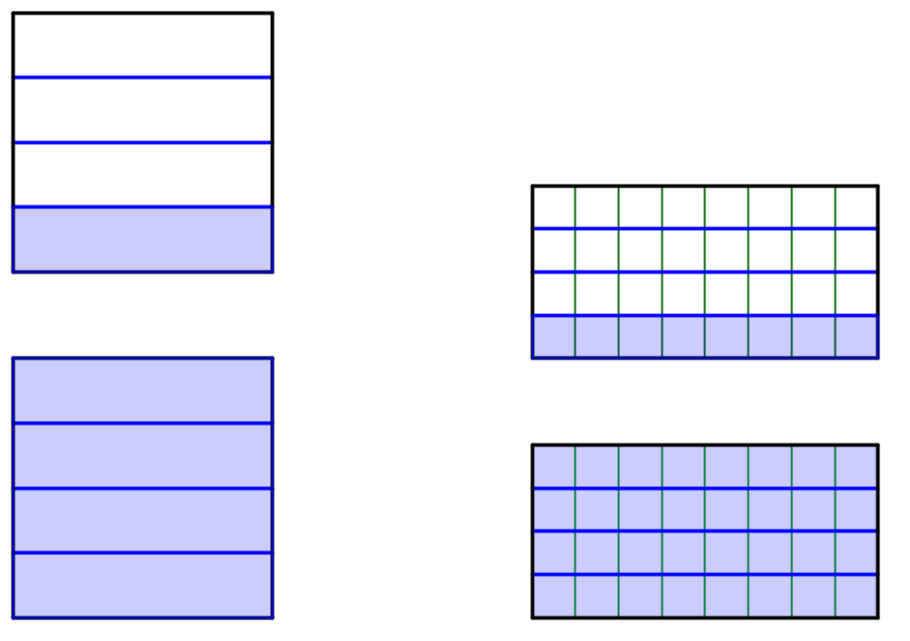
Now partition each of the fourths into 8 pieces by subdividing in the opposite direction. Add another pair of wholes so you can make 15/8.
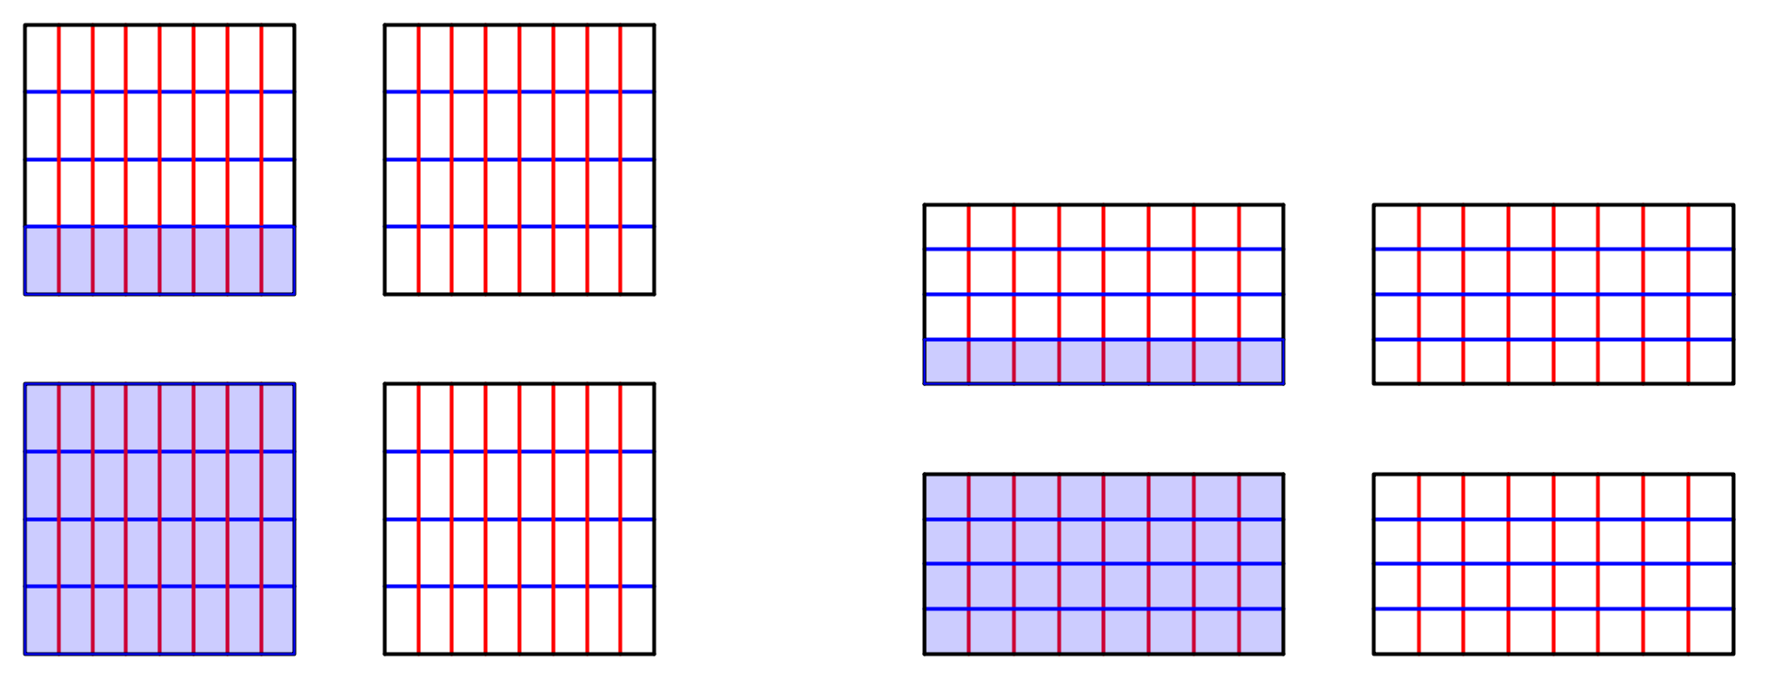
1/8 of 5/4

Figure out how much 1/8 of 5/4 is.

Now, show how much 15/8 of the 5/4 is by shading 15 pieces that are 1/8 of the part that’s shaded blue (the 5/4).
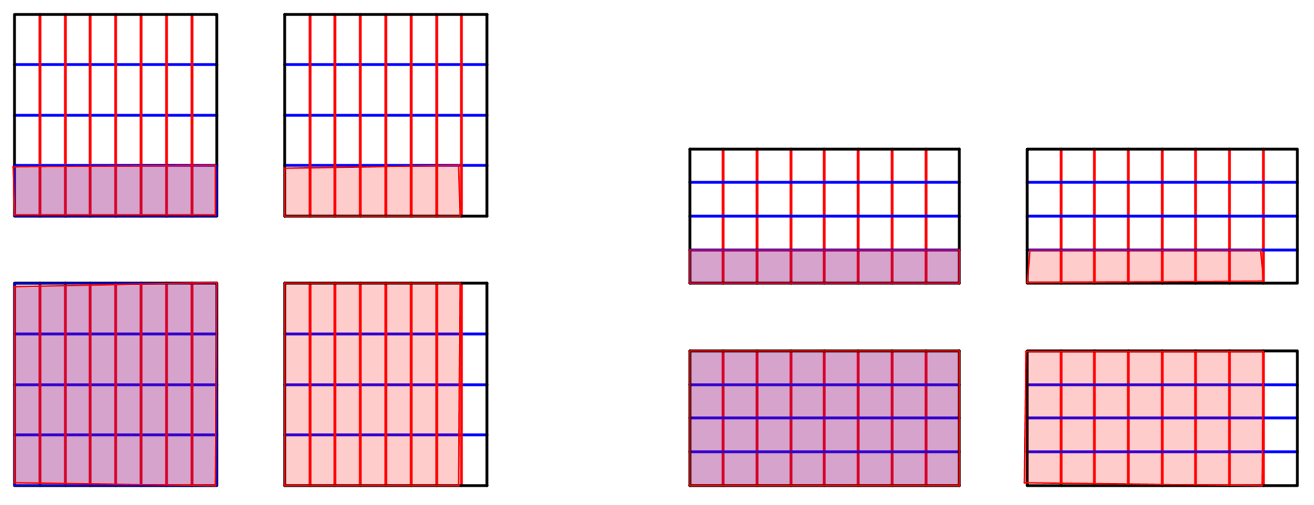
- This picture, along with my explanations of how I made it satisfies: Use a visual model
- And also: Explain in words the rationale for the visual model (can be either fraction of a fraction or rectangular area). My picture shows 5/8 taken of a set of size 3/4, so my model matches the words.
Note: you only need to show the final picture—not all three.

Now the whole square/rectangle that I started with was 1 unit of stuff. The blue part was 3/4 of a unit of stuff, and the red/purple is 5/8 of 3/4 of a unit of stuff. So—how many units is that?

I need to know how many boxes are in a whole unit of stuff. One way to figure out how many boxes there are is to count the number of rows (4) and columns (8) in 1 whole unit. You can multiply rows × columns to find the total number of boxes in the whole.

I need to know how many boxes are in 15/8 of 5/4: that’s the red/purple part. I can count the number of rows (5) and the number of columns (15) and multiply those to find the number of boxes in the product:

So the product is 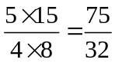 units.
Notice that the number of red parts is the product of the two numerators, and the number of parts in a whole is the product of the two denominators.

- In these paragraphs: The numerical strategy is shown
- And: There is an in-words explanation of how the numerical steps are shown in the diagram. This should include both:
  - How the numerator and the denominator values are shown in the diagram When I say/show that the number of parts in the red-shaded rectangle is the numerator, and the number of parts in a whole is the denominator I am doing this.
  - How the products can be deduced from the diagram (what to multiply together and why). When I explain that I am getting numbers from the rows and columns or recalling how I partitioned the whole I am doing this part.

